**Visvesvaraya Technological University**

## Jnana Sangama, Belagavi - 590018

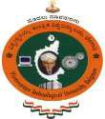

A Mini Project (BCS586)

Report on

**“ANIMAL HERD WELFARE MANAGEMENT SYSTEM”**

***Submitted in partial fulfilment of the requirement for the award of the degree of***

## BACHELOR OF ENGINEERING

IN

## COMPUTER SCIENCE AND ENGINEERING

**Submitted by**

**TEJA M S 1KS22CS165**

**TEJAS GOWDA H R 1KS22CS166**

**ULLAS S A 1KS22CS174**

**TARUN D N 1KS23CS415**

Under the guidance of

**Ms. Asha Sattigeri**

**Assistant Professor**

**Department of Computer Science & Engineering K.S.I.T, Bengaluru-560109**



**DEPARTMENT OF COMPUTER SCIENCE & ENGINEERING**

**K. S. Institute of Technology**

**#14, Raghuvanahalli, Kanakapura Road, Bengaluru - 560109 2024 - 2025**

K. S. Institute of Technology

**#14, Raghuvanahalli, Kanakapura Road, Bengaluru - 560109**

# Department of Computer Science & Engineering



**CERTIFICATE**

Certified that the Mini Project (BCS586) entitled **“ANIMAL HERD WELFARE MANAGEMENT SYSTEM”** is a bonafide work carried out by:

**TEJA M S 1KS22CS165**

**TEJAS GOWDA H R 1KS22CS166**

**ULLAS S A 1KS22CS174**

**TARUN D N 1KS23CS415**

in partial fulfilment for V semester B.E., Mini Project Work in the branch of Computer Science and Engineering prescribed by **Visvesvaraya Technological University, Belagavi** during the period of September 2024 to December 2024. It is certified that all the corrections and suggestions indicated for internal assessment have been incorporated in the report deposited in the department library. The Mini Project Report has been approved as it satisfies the academic requirements in report of mini project work prescribed for the Bachelor of Engineering degree.

**………………………… ..……………..……… …..…..……………………**

### Signature of the Guide Signature of the HoD Signature of the Principal &

**Director**

[Ms. Asha Sattigeri] [Dr. Rekha B. Venkatapur] [Dr. Dilip Kumar K]

**DECLARATION**

We, the undersigned students of 5th semester, Computer Science & Engineering, KSIT, declare that our mini project entitled “**ANIMAL HERD WELFARE MANAGEMENT SYSTEM**”, is a bonafide work of ours. Our mini project is neither a copy nor by means a modification of any other engineering mini project.

We also declare that this mini project was not entitled for submission to any other university in the past and shall remain the only submission made and will not be submitted by us to any other university in the future.

Place:Bengaluru

Date:

### Name and USN Signature

**TEJA M S (1KS22CS165) ………………….**

**TEJAS GOWDA H R (1KS22CS166) ………………….**

**ULLAS S A (1KS22CS174) ………………….**

**TARUN D N (1KS23CS415) ………………….**

**ACKNOWLEDGEMENT**

The satisfaction and euphoria that accompany the successful completion of any task will be incomplete without the mention of the individuals, we are greatly indebted to, who through guidance and providing facilities have served as a beacon of light and crowned our efforts with success.

First and foremost, our sincere prayer goes to almighty, whose grace made us realize our objective and conceive this project. We take pleasure in expressing our profound sense of gratitude to our parents for helping us complete our mini project work successfully.

We take this opportunity to express our sincere gratitude to our college **K.S. Institute of** **Technology,** Bengaluru for providing the environment to work on our mini project.

We would like to express our gratitude to our **MANAGEMENT,** K.S. Institute of Technology, Bengaluru, for providing a very good infrastructure and all the kindness forwarded to us in carrying out this mini project work in college.

We would like to express our gratitude to **Dr. K.V.A Balaji, CEO**, K.S. Institute of Technology, Bengaluru, for his valuable guidance.

We would like to express our gratitude to **Dr. Dilip Kumar K**, **Principal/Director**, K.S. Institute of Technology, Bengaluru, for his continuous support.

We like to extend our gratitude to **Dr. Rekha.B.Venkatapur**, **Professor and Head**, Department of Computer Science & Engineering, for providing a very good facilities and all the support forwarded to us in carrying out this mini project work successfully.

We also like to thank our Project Coordinators, **Mr. Roopesh Kumar B N, Associate Professor, Mr.** **Raghavendrachar S, Associate Professor, Department of Computer Science & Engineering** for their help and support provided to carry out the mini project work successfully.

Also, we are thankful to **Ms. Asha Sattigeri,** **Assistant Professor**, for being our Project Guide, under whose able guidance this mini project work has been carried out and completed successfully.

We are also thankful to the teaching and non-teaching staff of Computer Science & Engineering, KSIT for helping us in completing the mini project work.

**TEJA M S**

**TEJAS GOWDA H R**

**ULLAS S A**

**TARUN D N**

# ABSTRACT

The Animal Herd Welfare Management System Website is an innovative and comprehensive platform aimed at supporting farmers, particularly those managing herds of cows and buffaloes. The primary objective of this digital system is to streamline and enhance the welfare management of livestock by providing farmers with insights that improve herd health, increase productivity, and promote sustainable farming practices. This website offers a variety of integrated features designed to assist farmers in managing the key aspects of animal care, such as health monitoring, disease prevention, and overall farm management. Specifically focusing on cows and buffaloes, this system caters to the unique needs of these animals, which play a vital role in the agricultural and dairy industries.

Animal welfare management is crucial for farmers seeking to maintain healthy livestock, optimize production, and ensure sustainability in their farming operations. For centuries, traditional methods of livestock management have been used, but with advancements in technology, digital platforms are becoming increasingly important. These systems aim to provide real-time data and actionable insights that aid farmers in making informed decisions that positively impact both the welfare of the animals and the profitability of the farm.

The Animal Herd Welfare Management System is a web-based platform that serves as a central hub for managing the welfare of cows and buffaloes. It allows farmers to track various aspects of herd management, from health monitoring to breeding practices, ensuring that their animals receive the best possible care while enhancing productivity.

One of the most critical aspects of herd management is ensuring the health and well-being of the animals. Moreover, the platform provides recommendations on preventive measures, such as vaccinations and treatments, to keep the herd healthy and productive. By tracking these health metrics consistently, farmers can spot trends in the herd’s health and take proactive steps to address any emerging issues.

The AHWMS combines technology and practicality to deliver a comprehensive solution, supporting animal health, veterinary consultations, livestock trading, and government services accessibility in a user-friendly platform. It seeks to improve livestock welfare and productivity, which directly benefits the socio-economic conditions of farmers.

The primary objective of the AHWMS project is to empower farmers with a one-stop solution

that focuses on animal health management, marketplace facilitation, and connection to relevant government schemes. By utilizing a digital platform, AHWMS ensures that farmers can access essential veterinary services, order livestock feed, purchase animals, and benefit from government welfare programs without needing to travel long distances or rely solely on manual processes.

The implementation of the Animal Herd Welfare Management System has the potential to transform rural livestock management by bridging gaps in access to health services, marketplace opportunities, and government support. By leveraging digital solutions, the AHWMS enhances efficiency, transparency, and productivity in animal husbandry.

Furthermore, this project aligns with broader goals of rural development and digital empowerment, enabling farmers to improve their livestock welfare while enhancing their economic stability. Through this system, Karnataka’s farming community can lead the way in adopting sustainable and technology-driven livestock management practices.

# TABLE OF CONTENTS

|  |  |  |  |  |
| --- | --- | --- | --- | --- |
| **Chapter No.** | **Title** | | | **Page No.** |
| **1.** | **INTRODUCTION** | | | **1-7** |
| 1.1 | Background | | | 1-3 |
| 1.2 | Problem Statement | | | 4 |
| 1.3 | Objectives | | | 5 |
| 1.4 | Scope of the Project | | | 6-7 |
| **2.** | **LITERATURE SURVEY** | | | **8-12** |
| 2.1 | Existing systems | | | 8-9 |
| 2.2 | Comparison with Existing Systems | | | 9-11 |
| 2.3 | Research Summary | | | 12 |
| **3.** | SYSTEM REQUIREMENT SPECIFICATION (SRS) | | | **13** |
| 3.1 | Software Requirements | | | 13 |
| 3.2 | Hardware Requirements | | | 13 |
| **4.** | | **SOFTWARE DESIGN SPECIFICATION (SDS)** | **14-17** | |
| **5.** | | **DESIGN** | 18-19 | |
| 5.1 | | Work flow of the software | 18-19 | |
| **6.** | | **IMPLEMENTAION** | **20-23** | |
| 6.1 | | Technologies and Tools Used | 20-21 | |
| 6.2 | | Implementation Process | 22-23 | |
| **7.** | | **TESTING AND RESULTS** | **24-26** | |
| **8.** | | **SNAPSHOTS** | **27-28** | |
| **9.** | | **CONCLUSION** | **29** | |
| **10.** | | **FUTURE ENHANCEMENTS** | **30** | |
| **11.** | | **REFERENCES** | **31** | |
| **12.** | | **APPENDIX - I: Certificate of Online Course** | **32-33** | |

# LIST OF FIGURES

|  |  |  |
| --- | --- | --- |
| **Fig. No.** | **Figure Name** | **Page No.** |
| 5.1 | Work flow of the App | 18 |
| 7 | Compiling & Testing The App | 24-26 |
| 7.1(a) | Home Page | 24 |
| 7.2(b) | Marketing Dashboard | 24 |
| 7.3(c) | Market Price Dashboard | 25 |
| 7.4(d) | Crop Management Page | 25 |
| 7.5(e) | Governament Schemes Dashboard | 26 |
| 7.6(f) | Contact Page | 26 |
| 8.1 | Code-1 | 27 |
| 8.2 | Code-2 | 27 |
| 8.3 | Code-3 | 28 |
| 8.4 | Code-4 | 28 |

**Chapter 1**

**INTRODUCTION**

* 1. **Background**

In rural economies, particularly in developing regions, agriculture forms the foundation of livelihoods, and within this system, livestock farming serves as a cornerstone. Livestock such as cows, buffaloes, goats, and sheep are vital assets for farmers, contributing not only to their daily sustenance through milk, meat, and manure but also providing financial security during times of need. For many small and marginal farmers, livestock represents a form of wealth that can be relied upon in emergencies or sold to meet household expenses. In Karnataka, where agriculture dominates the rural landscape, livestock rearing is not merely a practice but a way of life, deeply embedded in cultural traditions and critical to the rural economy. The state has one of the highest livestock populations in India, making it a significant contributor to agricultural GDP and a key driver of employment in rural areas.

Despite its importance, the livestock sector faces numerous challenges that undermine its potential to improve rural livelihoods. The traditional methods of herd management are often inefficient and labor-intensive, relying heavily on manual practices that are not scalable or sustainable in modern agricultural contexts. One of the most pressing issues is the lack of timely and accessible veterinary care. In rural areas, veterinary services are often located far from villages, requiring farmers to travel long distances to seek treatment for their animals. This not only results in delays in addressing health issues but also increases the likelihood of disease outbreaks and productivity losses. Preventive care, such as vaccinations and regular check-ups, is often neglected due to these logistical challenges, further exacerbating the problem.

In addition to health-related challenges, farmers face barriers to accessing government schemes and subsidies that are designed to support livestock development. Programs like the Punyakoti Dattu Yojana, which encourages cow adoption and welfare, and the Animal Husbandry Infrastructure Development Fund (AHIDF), which provides financial support for modernizing livestock-related infrastructure, remain underutilized. This is largely due to a lack of awareness, inadequate dissemination of information, and complex application processes that discourage farmers from taking advantage of these benefits. Without a centralized system to connect farmers with these welfare programs, the gap between policy and implementation continues to widen, leaving many rural households unable to reap the intended benefits.

Livestock trading, another critical component of the sector, is fraught with inefficiencies. The current trading practices are largely informal and unregulated, making it difficult for farmers to obtain fair market prices for their animals. The lack of organized marketplaces and transparency in transactions often puts farmers at a disadvantage, as they are unable to negotiate effectively or reach a wider market for their livestock. This limits their earning potential and hinders their ability to reinvest in their herds, thereby creating a cycle of economic stagnation.

The Animal Herd Welfare Management System (AHWMS) emerges as a comprehensive solution to these challenges, aiming to revolutionize livestock farming practices by integrating modern technology with practical functionality.

The system is designed to provide farmers with a one-stop platform for managing animal health, accessing veterinary consultations, participating in livestock trading, and availing themselves of government welfare schemes. By digitizing these processes and making them accessible through a user-friendly interface in Kannada and English, the AHWMS addresses the barriers of distance, awareness, and complexity that currently plague the sector. The platform is not merely a tool but a transformative initiative that seeks to enhance livestock welfare, increase productivity, and improve the socio-economic conditions of farmers across Karnataka. By addressing the root causes of inefficiency and inequity in the livestock sector, the AHWMS holds the potential to create a more sustainable and prosperous future for rural communities.

* 1. **Problem Statement**

In Karnataka, livestock farming forms a critical component of rural livelihoods, contributing to the socio-economic well-being of farmers through milk, meat, and other income-generating activities. Despite its significance, the sector is plagued by systemic challenges that hinder productivity and economic growth. Farmers face significant barriers to accessing timely veterinary care, with rural areas often lacking nearby veterinary services, leading to delays in treatment and preventable livestock losses.

Furthermore, awareness and utilization of government welfare schemes, such as the Punyakoti Dattu Yojana and AHIDF, remain low due to limited outreach, complex processes, and the absence of a centralized information platform.

Livestock trading, another vital aspect of animal husbandry, is largely unregulated and informal, leaving farmers vulnerable to unfair pricing, inefficiencies, and limited market access. Traditional herd management practices are inefficient and fail to integrate with modern technological solutions, further compounding these issues. Language barriers, lack of digital literacy, and inadequate infrastructure in rural regions exacerbate the problem, leaving farmers unable to fully leverage existing resources or access essential services.

This fragmented system not only undermines livestock welfare but also prevents farmers from maximizing their economic potential, limiting the overall development of the agricultural sector. To address these pressing issues, there is an urgent need for a comprehensive, technology-driven platform that integrates animal health management, marketplace facilitation, and access to government schemes. By bridging the gap between farmers, veterinary services, and government welfare programs, such a solution can ensure better animal welfare, increased productivity, and improved economic outcomes for rural farming communities.

* 1. **Objectives**

1. Enhance livestock welfare and health by ensuring timely access to veterinary care through online consultations and preventive health measures, reducing livestock mortality and improving productivity.
2. Simplify access to government welfare schemes by integrating programs like Punyakoti Dattu Yojana, AHIDF, and Pashu Aushadha into a single platform, enabling farmers to easily access and apply for benefits without navigating complex processes.
3. Facilitate fair and transparent livestock trading by providing an online marketplace for buying and selling livestock and essential supplies, ensuring farmers receive fair market prices while eliminating inefficiencies in unregulated trading practices.
4. Promote economic growth for farmers by improving milk production, livestock productivity, and profitability through better herd management and access to quality feed, health services, and trading opportunities.
5. Leverage technology for rural empowerment by developing an easy-to-use, bilingual platform (Kannada and English) that ensures inclusivity and adoption among farmers, replacing traditional manual processes with efficient, scalable digital tools.
6. Bridge infrastructure and service gaps by reducing the need for farmers to travel long distances for veterinary services or government offices, providing centralized access to essential services and resources.
7. Foster sustainable livestock management practices by introducing modern tools and data-driven insights that encourage better animal husbandry, aligning with broader goals of rural development and technological empowerment of farming communities

**1.4 Scope of the Project**

1. Digital Veterinary Care Management  
   The AHWMS will provide a platform where farmers can schedule and access veterinary consultations through video, audio, or text-based communication. This feature will ensure that farmers can receive immediate and professional medical advice for their livestock without the need to travel long distances. The platform will also allow farmers to track health records, vaccination schedules, and treatments, ensuring that their animals receive timely and consistent care, thus improving overall herd health and productivity.
2. Livestock Trading and Marketplace  
   The platform will integrate a digital marketplace where farmers can buy and sell livestock such as cows, buffaloes, and other farm animals. The marketplace will be structured to ensure transparency and fairness in transactions by offering a standardized pricing system based on market conditions and animal health. Additionally, the platform will include the sale of essential livestock care supplies, such as animal feed, medicines, and veterinary tools. This will streamline the trade process and reduce the inefficiencies and unfair practices found in informal, unregulated markets.
3. Integration with Government Welfare Schemes  
   A significant feature of the AHWMS will be the integration of various government welfare schemes directly into the platform. Programs such as the Punyakoti Dattu Yojana, Animal Husbandry Infrastructure Development Fund (AHIDF), and Pashu Aushadha will be easily accessible, allowing farmers to learn about, apply for, and track their eligibility and benefits under these schemes. This integration will eliminate the need for farmers to visit multiple government offices and ensure they can access financial aid, subsidies, and other welfare programs designed to support livestock farming.
4. Livestock Health and Productivity Management  
   The AHWMS will offer tools for farmers to monitor the health and productivity of their animals. This will include tracking milk production, weight gain, and general health status, as well as providing reminders for important vaccinations, breeding schedules, and other management activities. Farmers will be able to maintain comprehensive digital records of their livestock, which will help them make informed decisions about breeding, selling, and care, thus enhancing productivity and animal welfare.
5. Bilingual User Interface (Kannada and English)  
   The platform will be designed with a bilingual user interface that supports both Kannada and English. This will ensure accessibility and ease of use for farmers across Karnataka, considering the diverse literacy levels and language preferences in rural communities. The interface will be simple, intuitive, and responsive, allowing farmers with limited digital literacy to navigate and utilize the system effectively, while also providing a comprehensive and user-friendly experience for those more familiar with technology.
6. Reduced Dependence on Physical Infrastructure  
   By offering a fully digital solution, AHWMS will reduce the need for farmers to travel long distances to access veterinary services, government offices, or marketplaces. This will address a significant challenge in rural areas where infrastructure may be sparse and access to essential services is limited. The platform’s digital nature will empower farmers to manage their livestock's health, access government schemes, and participate in livestock trading directly from their mobile devices or computers, saving time and costs associated with physical travel.
7. Promotion of Sustainable Livestock Management Practices  
   The AHWMS will include tools and features that encourage sustainable and modern livestock management practices. This will include guidelines on efficient feeding, waste management, and animal health practices that reduce environmental impact and improve the long-term sustainability of farming operations. Additionally, the platform will offer insights based on data collected from farmers, enabling the system to provide personalized recommendations that support both the economic and environmental sustainability of livestock farming.

**Chapter 2**

**LITERATURE SURVEY**

**2.1 Existing Systems**

1. Telemedicine Platforms for Veterinary Care  
   Existing telemedicine platforms, such as TeleVet in India and VetScan globally, have become essential tools for delivering veterinary consultations to farmers in rural areas. These systems enable farmers to access veterinary advice remotely, addressing the challenge of long distances to veterinary clinics. They provide video, audio, or text-based consultations to ensure timely intervention in the care of livestock. These platforms often include features like disease diagnosis, medication prescriptions, and advice on preventive health care. However, these systems are often standalone solutions focusing primarily on veterinary care, lacking integration with broader livestock management tasks such as trading or access to government schemes. Moreover, some platforms face challenges in regions with poor internet connectivity or digital literacy, which limits their reach and effectiveness in certain rural areas.
2. Digital Livestock Marketplaces  
   Several digital platforms have been developed to facilitate livestock trading, aiming to improve transparency and market access for farmers. Systems such as KisanMitr and AgriDigital provide a digital marketplace for buying and selling livestock. These platforms enable farmers to connect with buyers and sellers directly, reducing the need for intermediaries and ensuring better pricing for both parties. The marketplaces often feature standardized pricing systems based on real-time market conditions and livestock health data, helping ensure fairer transactions. However, these platforms may still face challenges regarding regulation and the enforcement of pricing standards, as livestock trading in many rural areas remains informal and unregulated. Additionally, these systems often do not incorporate integrated health management features or government scheme access, limiting their effectiveness in improving overall livestock welfare.
3. Government Welfare Scheme Integration Platforms  
   Digital platforms that integrate government welfare schemes for farmers, such as eNAM and PM-KISAN, have been designed to improve farmers' access to subsidies, grants, and other government services. These platforms streamline the application and disbursement processes for various agricultural welfare programs. For example, eNAM connects farmers to a national agricultural market, where they can access government-supported pricing and trading systems. Similarly, PM-KISAN provides financial assistance to eligible farmers through a mobile app and online portal. While these systems improve access to government schemes, they often fail to incorporate the specific needs of livestock farmers, such as veterinary care or livestock-specific subsidies, and are not tailored to address the full spectrum of challenges within the livestock sector. Moreover, the lack of integration with animal health management systems makes them less comprehensive for farmers dealing with livestock.
4. IoT and Data Analytics in Livestock Management  
   Advances in Internet of Things (IoT) and data analytics have led to the development of systems that help monitor and manage livestock health and productivity. Platforms like SmartFarm and various IoT-based solutions for livestock monitoring enable farmers to track key health metrics, such as weight, milk production, and feed consumption. These platforms often use wearable sensors on animals to collect data, which is then analyzed to provide insights and recommendations for improving herd management. Such systems have proven valuable in increasing livestock productivity and reducing health-related issues. However, these platforms generally focus on the technical aspects of livestock management and may not integrate well with other components such as veterinary consultations, trading platforms, or access to welfare schemes. Additionally, the high cost of IoT infrastructure and the complexity of data analytics can be barriers for small-scale farmers.
5. Mobile Applications for Livestock Management  
   Mobile applications designed for livestock management have gained popularity in regions like India, where mobile penetration is high. These apps offer functionalities like livestock record keeping, health tracking, and market price updates.While these systems are accessible and relatively affordable for small farmers, they often lack comprehensive functionalities such as an integrated veterinary service, trading capabilities, and personalized care plans. Moreover, their reliance on smartphone availability and internet access in rural areas can limit their adoption.

**2.2 Comparison with Existing Systems**

The Animal Herd Welfare Management System (AHWMS) integrates veterinary care, livestock trading, and government welfare schemes into a single digital platform aimed at addressing key challenges faced by livestock farmers. A comparison with existing systems highlights the advantages and areas where AHWMS seeks to fill gaps in the current landscape.

1. Veterinary Care Systems  
   Existing systems such as TeleVet and VetScan focus primarily on providing remote veterinary consultations. These platforms allow farmers to access veterinary advice through phone calls, video consultations, or chat. While they are highly beneficial in providing timely medical intervention, they primarily address the health aspect of livestock management. The limitation lies in their narrow focus, as they do not integrate with broader livestock management tasks such as marketplace transactions or government support. AHWMS, on the other hand, extends beyond just healthcare by incorporating functionalities for livestock trading, government welfare access, and other management tools, creating a more holistic platform for farmers.
2. Livestock Trading Platforms  
   Several digital platforms, including KisanMitr and AgriDigital, focus on facilitating livestock trading. These platforms aim to reduce inefficiencies in traditional markets by connecting buyers and sellers directly, ensuring better pricing and market access. However, these systems tend to operate separately from veterinary care and government services. For instance, AgriDigital facilitates livestock trading but does not provide features for health management or access to welfare programs. The AHWMS is more comprehensive, offering not just a marketplace but also tools to track animal health, manage feed consumption, and access relevant government schemes, addressing multiple aspects of livestock management in one platform.
3. Government Welfare Scheme Integration  
   Digital platforms such as eNAM and PM-KISAN help farmers access government schemes, providing financial assistance and promoting transparency in agricultural markets. However, these platforms are designed for broader agricultural use and often do not cater specifically to the unique needs of livestock farmers, such as access to veterinary care or livestock-specific financial support. Additionally, the integration of such schemes into digital platforms remains fragmented, requiring farmers to navigate multiple systems for different services. In contrast, the AHWMS seamlessly integrates government welfare programs such as Punyakoti Dattu Yojana and AHIDF, ensuring that farmers can easily apply for and benefit from these schemes directly through the platform, making the process simpler and more streamlined.
4. IoT and Data Analytics in Livestock Management  
   Systems like SmartFarm and IoT-based livestock monitoring solutions focus on data-driven management of livestock, using sensors and analytics to track health parameters such as weight, milk production, and feed consumption. These systems help optimize herd management by providing actionable insights. However, they are often limited in their scope, focusing only on health and productivity, and may lack integration with other critical services such as veterinary consultations or trading. The AHWMS improves on this by incorporating data analytics for livestock health and productivity while also linking it with the ability to consult with veterinarians and access government schemes, making the platform more holistic

**2.3 Research Summary**

The Animal Herd Welfare Management System (AHWMS) is a proposed digital solution aimed at transforming the way farmers manage livestock health, productivity, and welfare in rural areas. This system is designed to address the various challenges faced by farmers, especially in regions like Karnataka, where access to veterinary care, market opportunities, and government welfare schemes is often limited.

Current systems in livestock management primarily focus on specific aspects, such as veterinary care, livestock trading, and government services. However, they often operate in isolation, which leaves gaps in addressing the full spectrum of farmer needs. For instance, while telemedicine platforms provide remote veterinary consultations, they lack integration with marketplace functionalities or government scheme access. Similarly, digital trading platforms facilitate livestock transactions but do not address the health or welfare aspects of livestock. Government welfare scheme platforms, while valuable for accessing subsidies, do not cater specifically to the needs of livestock farmers.

The AHWMS aims to fill these gaps by offering a comprehensive platform that integrates essential components such as veterinary care, livestock trading, and government welfare schemes. This system allows farmers to access veterinary consultations through video, audio, or text, manage their livestock through an integrated marketplace, and apply for relevant government programs like Punyakoti Dattu Yojana and AHIDF. By consolidating these services, the AHWMS eliminates the need for farmers to navigate multiple systems and provides a one-stop solution for managing livestock welfare.

Additionally, the AHWMS introduces data analytics and IoT-based monitoring to track livestock health and productivity, helping farmers make informed decisions regarding animal care, feed, and market conditions. This data-driven approach can lead to better health outcomes and improved economic stability for farmers by reducing livestock losses and improving productivity.

Furthermore, the platform’s dual language support in Kannada and English ensures that it is accessible to a wide range of farmers, regardless of literacy levels or digital familiarity. The system’s user-friendly interface, designed for both smartphone and feature phone users, maximizes adoption rates among rural populations.

**Chapter 3**

**SYSTEM REQUIREMENT SPECIFICATION (SRS)**

### 3.1 SOFTWARE REQUIREMENTS

**Technologies [Frontend]:**

* HTML
* CSS
* Java Script

**Technologies [Backend]:**

Django

**Tools:**

PyCharm

### HARDWARE REQUIREMENTS

PC/Laptop.

**Chapter 4**

**SOFTWARE DESIGN SPECIFICATION (SDS)**

The Animal Herd Welfare Management System (AHWMS) is a digital platform designed to assist farmers in managing livestock health, welfare, and marketplace activities. The platform integrates various features such as veterinary care, livestock trading, and government welfare scheme access. This software design specification outlines the design and technical requirements for the development of the system using tools like HTML, CSS, JavaScript, Django, and PyCharm.

1. System Overview

The system is built with a client-server architecture, where the frontend (user interface) interacts with the backend (server-side logic and database). The frontend will be developed using HTML, CSS, and JavaScript, while the backend will be built using Django. PyCharm will be the integrated development environment (IDE) for developing and testing the backend code.

1. Frontend Design

The frontend will be the part of the system that interacts with users. The design will be simple, intuitive, and responsive to ensure ease of use for farmers, including those with limited technical skills. Key components and tools used for frontend development are:

* HTML: The structure of the web pages will be created using HTML. It will define the layout and content of the web pages, including forms for user inputs, buttons for navigation, and tables for displaying data.
* CSS: Styling of the web pages will be handled using CSS. This will ensure the system has an aesthetically pleasing and user-friendly interface. The design will be responsive, ensuring that the system works on various devices, such as smartphones, tablets, and desktops.
* JavaScript: JavaScript will be used for client-side interactivity. This includes form validation, dynamic updates to the page (such as populating tables or updating livestock listings), and AJAX calls to fetch or submit data without refreshing the page. JavaScript will enhance the user experience by allowing smoother navigation and quick updates to the page.

1. Backend Design

The backend of the AHWMS will be developed using the Django framework. Django is a robust Python-based web framework that will handle the server-side logic, database management, and integration with external services. Key components and tools used for backend development are:

* Django: The Django framework will be used to create the backend API and handle business logic. It will facilitate efficient routing of requests, user authentication, session management, and integration with the database. Django’s built-in features like the Admin Panel will be used for managing the system’s data and user activities.
* Database: The system will use SQLite (for development and testing) and later migrate to PostgreSQL or MySQL for production. Django’s Object-Relational Mapping (ORM) will be used to interact with the database, allowing the system to store and retrieve data efficiently. Data such as user profiles, livestock details, transaction records, and consultation history will be managed using the database.
* Python (Django): The server-side code will be written in Python. Django will handle routing, URL management, and data handling, making it easy to implement business logic, perform CRUD operations (Create, Read, Update, Delete), and return responses to the frontend. The Python-based backend will handle tasks like authentication, session management, data validation, and integration with external APIs (such as payment gateways and government schemes).

1. User Interface Design

The user interface (UI) will be designed with simplicity in mind, ensuring farmers can easily navigate the system without confusion. The UI will be developed with HTML, CSS, and JavaScript:

HTML will define the structure, including navigation menus, data tables, forms for entering livestock details, and buttons for user actions.

CSS will be used to ensure the system’s UI is responsive and visually appealing. It will adjust the layout for different screen sizes, making it compatible with both mobile phones and desktops.

JavaScript will enable dynamic content loading (such as new veterinary consultations or updated livestock listings) without refreshing the page. It will also provide validation for user input, ensuring that data is correctly formatted before submission.

1. Security Features

The security of the platform is critical, especially for safeguarding user data and sensitive information related to livestock, payments, and government schemes. Key security features include:

* Django’s Authentication System: Django provides built-in authentication and session management, which will be used to manage user login, registration, and access control based on roles (farmer, administrator, veterinary staff).
* HTTPS and SSL: All communications between the client and server will be encrypted using HTTPS and SSL/TLS certificates, ensuring secure data transmission.
* Input Validation and Protection: Input from users will be validated both client-side (using JavaScript) and server-side (using Django) to prevent malicious inputs such as SQL injection and cross-site scripting (XSS). Django’s ORM will help prevent SQL injection by using parameterized queries.
* Password Encryption: User passwords will be securely stored in the database using Django’s built-in password hashing mechanisms.

1. Performance Considerations

The system will be designed for scalability and high performance:

* Caching: To reduce load times and improve performance, frequently accessed data (such as livestock listings and transaction histories) will be cached using Django’s caching mechanisms.
* Asynchronous Processing: For tasks such as sending notifications or processing heavy data (like veterinary consultations), asynchronous processing using Django’s Celery will be implemented to prevent blocking the main request-response cycle.
* Database Optimization: The database will be optimized by indexing frequently queried fields, minimizing joins, and normalizing data. Django’s query optimization tools will be used to ensure efficient database operations.

1. Development and Deployment Tools

* PyCharm: The PyCharm IDE will be used for developing the Django backend. PyCharm provides useful features such as code completion, debugging, and version control integration, which will accelerate the development process.
* Version Control: Git will be used for version control to manage code changes, collaborate with team members, and track progress. GitHub or GitLab will be used to host the repository.
* Deployment: The system will be deployed on Heroku or AWS for production. These cloud platforms provide scalable and secure hosting, automatic scaling, and integration with other services such as databases and storage.

1. Testing and Quality Assurance

The system will undergo thorough testing to ensure it meets functional, performance, and security requirements:

* Unit Testing: Django’s built-in unit test framework will be used to write and run tests for each module and function, ensuring that each component works as expected.
* Integration Testing: The system will be tested as a whole, including the interaction between frontend and backend, to ensure smooth data flow and correct behavior.
* User Testing: Farmers will participate in user acceptance testing (UAT) to ensure the system is user-friendly and meets their needs. Feedback from testing will be used to refine the system.

1. Conclusion

The Animal Herd Welfare Management System (AHWMS) will be developed using HTML, CSS, JavaScript, Django, and PyCharm to create a robust, scalable, and secure platform that helps farmers manage livestock health, welfare, and trade. The system’s comprehensive design ensures that all aspects of livestock management are integrated into one easy-to-use platform, improving efficiency, productivity, and access to government schemes.

**CHAPTER 5**

**DESIGN**

* 1. **Work flow of the software**

The Animal Herd Welfare Management System (AHWMS) will facilitate the efficient management of livestock health, trading, and government welfare schemes through a digital platform. Below is a detailed workflow of the system, describing how users interact with it from login to performing various tasks:

1. User Registration & Login

* Farmer/User registers for the system by providing personal details (name, phone number, address, etc.) and credentials (username and password).
* After registration, the user can log in to the system using their username and password.
* The system will authenticate the user and grant access based on their role (farmer, veterinary staff, administrator).

2. Dashboard Overview

Once logged in, the user is directed to their dashboard, where they can see an overview of:

* Livestock health status.
* Available government schemes.
* Upcoming veterinary consultations.
* Livestock market transactions.

3. Livestock Management

a) Adding and Managing Livestock

* The farmer can add new livestock details, including species (cow, buffalo), breed, age, health status, and vaccination history.
* This information is stored in the database and can be updated at any time.

b) Veterinary Services Request

* The farmer can initiate a request for veterinary consultation by choosing the required service (e.g., treatment for illness, vaccination, etc.).
* The system will offer remote veterinary consultations (video, audio, or chat).
* A notification is sent to available veterinary staff, who can then respond to the request with advice, prescriptions, or treatment plans.
* The consultation details, including diagnosis and treatment records, are saved for future reference.

4. Marketplace Management

a) Buying and Selling Livestock

* The farmer can post livestock for sale in the marketplace by entering information such as species, breed, price, and location.
* Other users (farmers or traders) can browse available livestock listings.
* Potential buyers can contact sellers via the platform for negotiations and purchase details.
* Transactions are completed through secure payment integration, with details logged for both parties.

b) Purchase of Livestock Feed and Supplies

* Farmers can also buy livestock feed and veterinary supplies directly from the platform.
* The marketplace will display a catalog of available supplies, including pricing and suppliers.

5. Government Services Integration

Accessing Welfare Schemes

* The system provides easy access to government schemes like Punyakoti Dattu Yojana, AHIDF, and Pashu Aushadha.
* The farmer can check eligibility, view scheme details, and apply for the scheme directly through the platform.
* The system will send notifications about the status of applications (approved, rejected, pending).

6.Administrator Panel

* The administrator (system manager) has access to all data on the platform. The admin panel allows for:
* User management (approving or suspending user accounts).
* Monitoring transactions and ensuring the platform’s integrity.
* Managing marketplace listings (approving or removing livestock listings).
* Overseeing welfare schemes and ensuring the correct processing of applications.
* Generating reports on system activity, including user statistics, transaction volumes, and health service requests.

**Chapter 5**

**IMPLEMENTAION**

The Animal Herd Welfare Management System (AHWMS) implementation involves the development and deployment of a digital platform that integrates various features, such as livestock management, veterinary services, marketplace functionality, and access to government welfare schemes. This section outlines the steps for implementing the system, including its architecture, tools, and methods for backend, frontend, and integration.

1. System Architecture

The AHWMS is designed using a client-server architecture, where the client-side (user interface) communicates with the server-side (backend) to fetch and submit data. The architecture can be broken down into the following components:

* Frontend (Client-side): This will be the interface through which farmers interact with the system. It is developed using HTML, CSS, JavaScript, and may involve the use of a framework like Bootstrap for responsiveness.
* Backend (Server-side): The backend will be developed using Django, a Python-based web framework. It will handle user authentication, data processing, and the connection to the database.
* Database: The database will be handled by SQLite during development and migrated to a more robust system like PostgreSQL or MySQL for production. Django’s ORM will be used to interact with the database, ensuring ease of data management.

2. Development Tools and Environment

* HTML/CSS/JavaScript: These are used for building the user interface and ensuring it is responsive. JavaScript will also handle dynamic content updates (like displaying livestock listings or consultation results).
* Django: This will be used for the backend of the application, which includes building models for livestock, users, transactions, and consultations. Django will also handle routing, authentication, and form submissions.
* PyCharm: PyCharm will be used as the Integrated Development Environment (IDE) for writing the backend code, running tests, and debugging the system.
* Database: Initially, SQLite is used as a lightweight, file-based database. For production, PostgreSQL or MySQL will be employed for scalability and performance.
* Version Control: Git will be used to manage the codebase. The repository will be hosted on GitHub or GitLab for collaborative development and version control.
* Cloud Hosting: The system can be deployed on Heroku, AWS, or Google Cloud, which provide scalable infrastructure for the application.

3. Backend Implementation (Using Django)

a) User Authentication and Authorization

* Django's built-in authentication system will be utilized for handling user registration, login, and access control.
* Users will be assigned roles (e.g., Farmer, Veterinary Staff, Administrator), and each role will have different levels of access to system features.

b) Models (Database Design)

* Livestock Model: A model to store details about livestock (species, breed, age, health status, and vaccination history).
* Consultation Model: A model to store details about veterinary consultations, including the type of service, date, and treatment history.
* Transaction Model: To track the sale and purchase of livestock, veterinary services, and supply transactions.
* Welfare Scheme Model: To track farmer eligibility and application status for government welfare schemes.

Each model will use Django’s ORM (Object-Relational Mapping) to interact with the database.

c) Views and URL Routing

* Views will handle the business logic, such as fetching livestock details, processing veterinary consultation requests, and managing marketplace listings.
* URL Routing will map the URLs in the frontend to corresponding views in the backend.

d) APIs (If applicable)

* If the system requires integration with third-party services (e.g., payment gateways or government APIs), Django will expose REST APIs using Django Rest Framework (DRF).

4. Frontend Implementation (HTML, CSS, JavaScript)

a) Responsive Design

* HTML will be used to structure the user interface (UI), including forms, buttons, and data tables.
* CSS will be used to style the UI. A responsive layout will be ensured by using media queries and frameworks like Bootstrap, which automatically adjusts the design based on the user’s device (mobile, tablet, desktop).
* JavaScript will be used to handle dynamic page updates and to fetch data from the backend via AJAX without requiring a page reload. This will be crucial for displaying real-time updates for livestock listings, transaction history, and veterinary consultations.

b) User Interface (UI) Components

* Forms for adding and updating livestock information, applying for government schemes, and scheduling veterinary consultations.
* Tables to display lists of livestock, transactions, and consultations.
* Interactive Maps or Search Features for locating livestock or finding nearby veterinary services.

5. Integration of Key Features

a) Veterinary Services

* A feature for scheduling veterinary consultations will be implemented using forms and video/audio integration (via APIs like Twilio for video calls or WebRTC for peer-to-peer video).
* The system will allow for real-time notifications (via SMS or app push notifications) to farmers about upcoming consultations or prescription availability.

b) Marketplace for Livestock and Supplies

* The marketplace will allow farmers to list livestock for sale, purchase livestock from others, and buy veterinary supplies or feed.
* Livestock listings will include details such as breed, age, price, and location.
* Payment gateways (e.g., Razorpay, Paytm, or Stripe) will be integrated for secure transactions.

c) Government Welfare Scheme Integration

* The system will allow farmers to apply for government schemes like Punyakoti Dattu Yojana and AHIDF.
* Each application will be tracked, and farmers will receive real-time updates about their application status.

d) Notifications and Alerts

* The system will send automated notifications for important events, such as consultation reminders, transaction updates, and government scheme approvals.
* Email and SMS integration will be used to ensure that users receive timely notifications.

6. Deployment

Once the development is completed, the system will be deployed in the following stages:

a) Development and Testing

* The system will be first deployed in a development environment (using a tool like Heroku or AWS EC2) for internal testing.
* Unit tests and integration tests will be run to ensure that the features are working as expected. The code will be versioned and tested using Git and GitHub.

b) Production Deployment

* After successful testing, the system will be deployed to a production environment.
* The system will be hosted on a cloud platform like Heroku, AWS, or Google Cloud.
* The database will be migrated to PostgreSQL or MySQL for production, ensuring scalability and performance.

7. Security Considerations

To ensure the security and integrity of the system, the following measures will be implemented:

* HTTPS/SSL: All data transferred between the client and server will be encrypted using HTTPS and SSL certificates.
* Password Hashing: User passwords will be hashed and stored securely using Django’s built-in hashing mechanism.
* Role-Based Access Control: User permissions will be defined based on roles (farmer, veterinarian, admin) to restrict access to sensitive features.
* Regular Security Audits: Regular audits and penetration testing will be conducted to identify and resolve security vulnerabilities.

**Chapter 7**

**TESTING AND RESULTS**

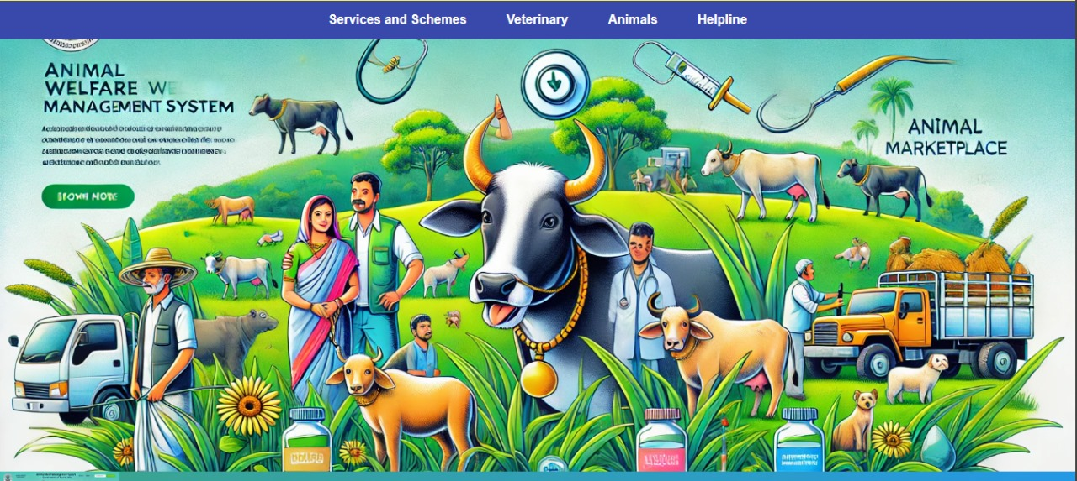

7.2(a) Dashboard.

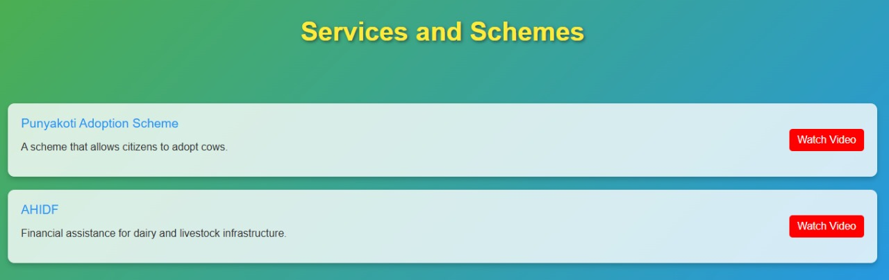

7.3(b) Services and Schemes

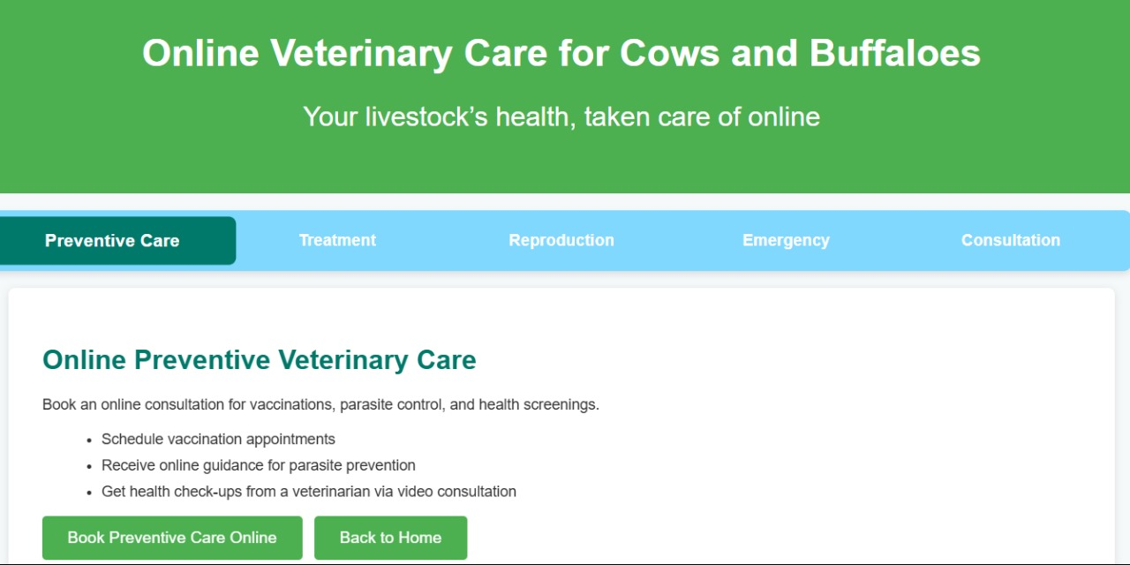

7.4(c) Veterinary Care

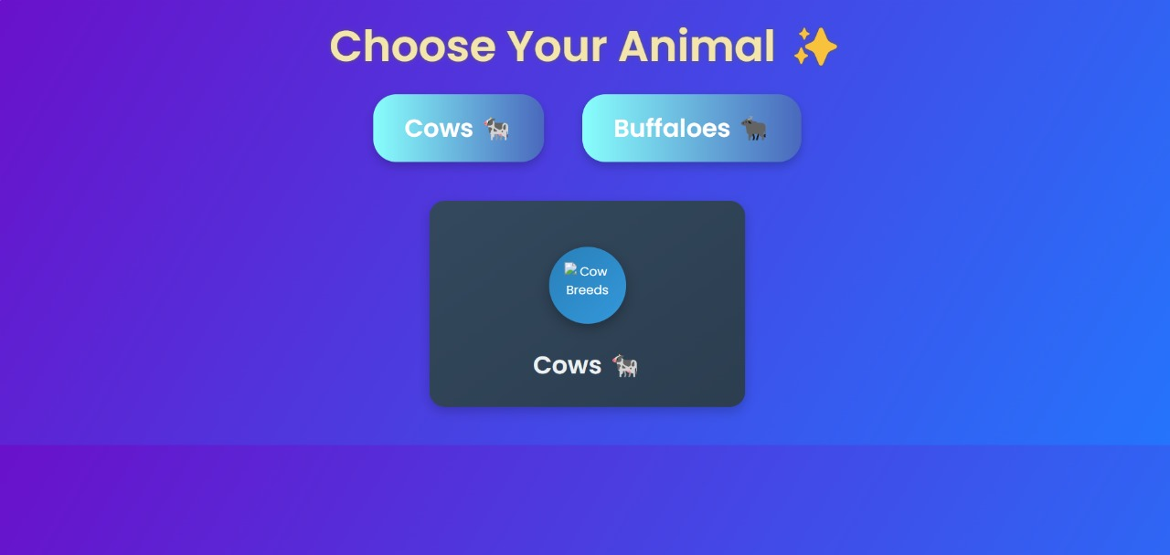

7.5(d) Animal

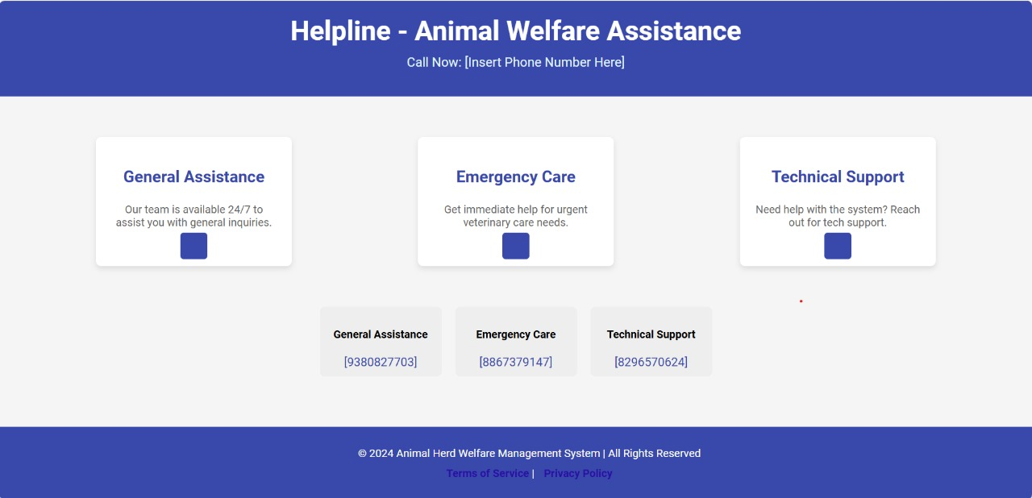

7.6(e) Helpline

**Chapter 8**

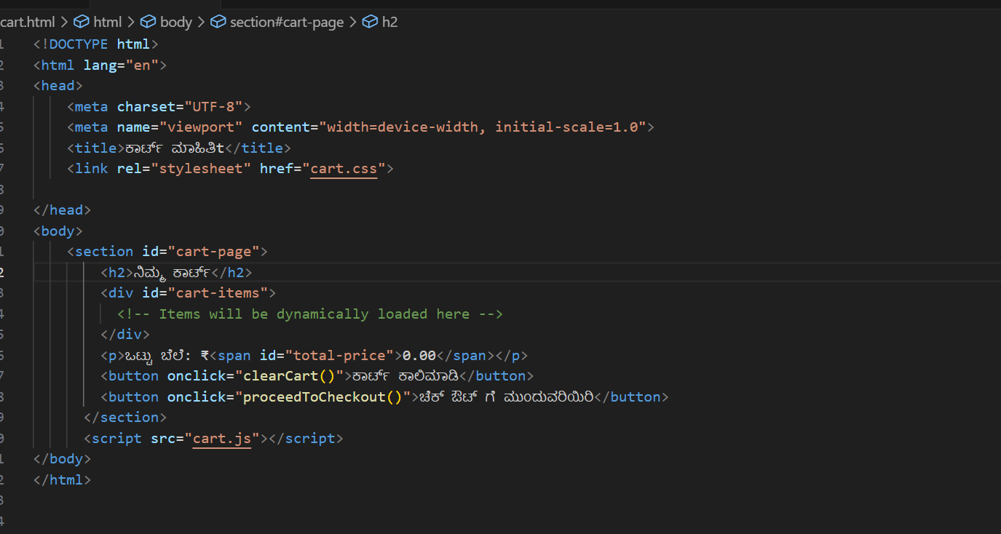 **SNAPSHOTS**

**8.1(a)Code-1**

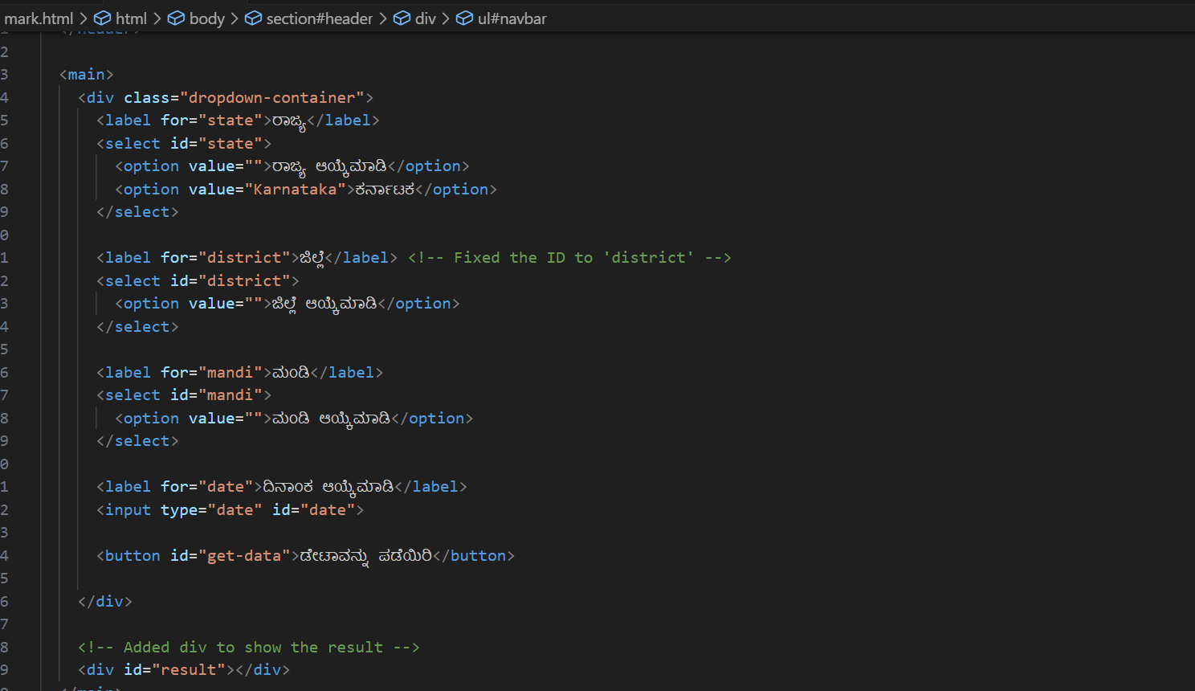

**8.2(b)Code-2**

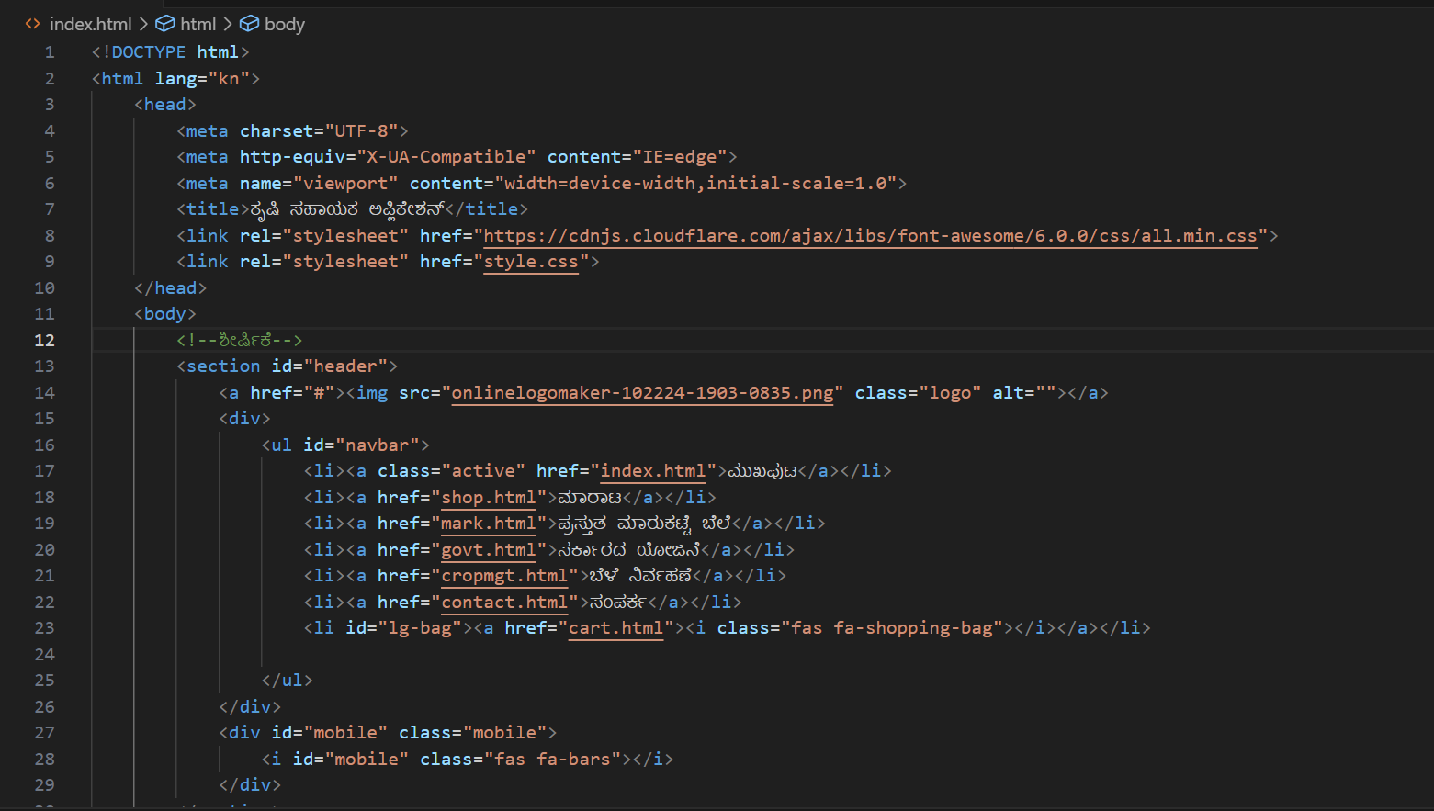

**8.3(c)Code-3**

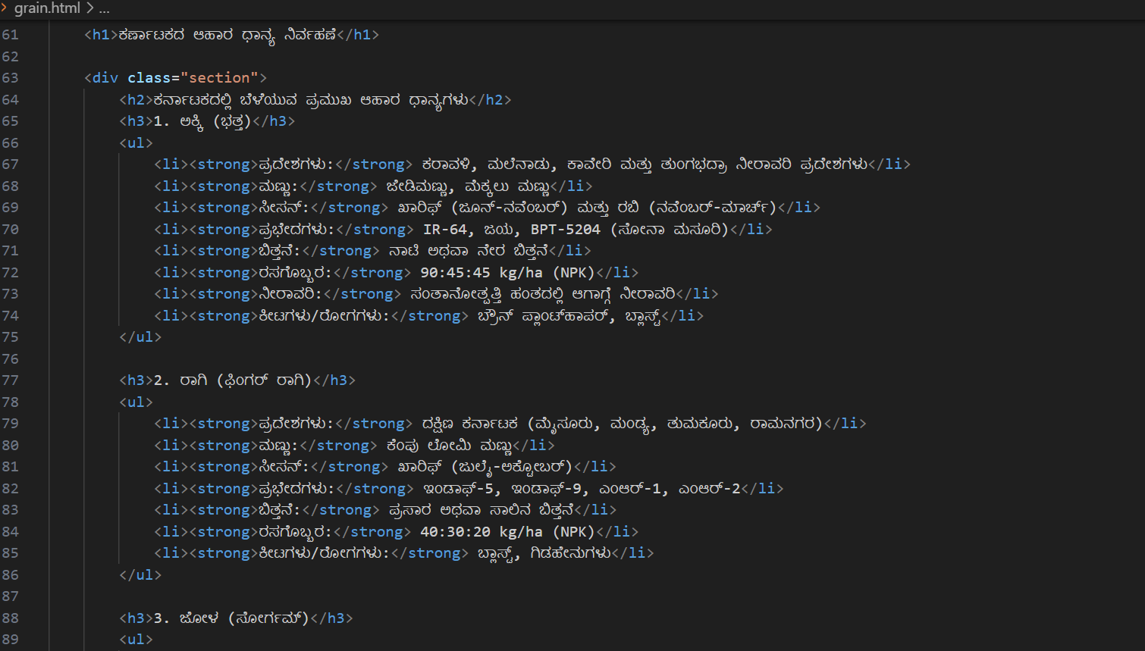

**8.4(d)Code-4**

**Chapter 9**

**CONCLUSION**

The Animal Herd Welfare Management System (AHWMS) is a pioneering project designed to address the critical challenges faced by farmers in rural areas, particularly in managing livestock and ensuring their welfare. Livestock farming is an integral part of rural economies, especially in regions like Karnataka, where cows, buffaloes, and other animals are crucial for milk production, meat, and additional sources of income. However, traditional livestock management methods are often inefficient and hindered by challenges such as the lack of access to veterinary care, limited knowledge about government schemes, and the informal and often exploitative nature of livestock trading.

By introducing a digital-first approach, AHWMS aims to provide a comprehensive solution that integrates veterinary care, livestock marketplace facilitation, and government welfare scheme access into a single, user-friendly platform. This system not only simplifies the process of managing animal health, improving productivity, and reducing livestock losses but also empowers farmers by connecting them with essential services and support systems that were previously out of reach due to geographical or financial constraints.

One of the core benefits of AHWMS is the ability to provide timely and accessible veterinary services. This eliminates the delays that often result in poor health outcomes for animals, ultimately improving livestock welfare and reducing economic losses. Additionally, the system integrates government welfare schemes like Punyakoti Dattu Yojana and AHIDF, ensuring that farmers can easily apply for financial assistance and other benefits that they may otherwise be unaware of.

Moreover, the marketplace component of the system enables farmers to buy and sell livestock in a more transparent and regulated environment. This eliminates the risks associated with informal livestock trading, where farmers often face unfair pricing and lack bargaining power. By providing a structured marketplace, AHWMS ensures fair prices and transparency in livestock transactions, which directly benefits farmers’ income and economic stability.

The AHWMS is also designed with inclusivity in mind, offering dual-language support in Kannada and English to cater to the diverse literacy levels and language preferences of farmers. This ensures that the system is accessible to a broad user base, empowering farmers to take full advantage of the platform’s capabilities.

**Chapter 10**

**FUTURE ENHANCEMENTS**

The Animal Herd Welfare Management System (AHWMS) has the potential for significant further enhancements that can build upon its existing features and provide additional value to farmers, veterinarians, and the broader agricultural ecosystem. These enhancements can be aimed at improving functionality, scalability, and user experience while incorporating emerging technologies and addressing evolving needs in the agricultural sector.

One of the key enhancements could be the integration of Artificial Intelligence (AI) and Machine Learning (ML) to analyze livestock health and productivity data. By using AI algorithms, the system could predict potential health issues in livestock based on historical data and behavioral patterns. This would allow for proactive veterinary care, reducing the risk of diseases spreading and ensuring better animal welfare. For example, AI could help identify early signs of diseases such as mastitis in dairy cows or other common livestock ailments, triggering early intervention by veterinarians.

Another area for improvement is the integration of Internet of Things (IoT) devices. These devices can provide real-time monitoring of livestock health, location, and environmental conditions. Sensors could be used to track vital signs like temperature, heart rate, or movement patterns of animals, sending alerts to farmers and veterinarians if any abnormal readings are detected. IoT-enabled systems could also monitor environmental conditions in livestock housing, ensuring optimal living conditions for the animals, such as temperature and humidity levels.

Expanding the marketplace functionality could also offer a major enhancement to the platform. By introducing features like auctioning systems or bidding platforms, farmers can engage in real-time trading of livestock and related products, helping them get the best possible prices. This would create more dynamic interactions between buyers and sellers, making the marketplace even more competitive and fair. Additionally, integrating a logistics and transportation module to help farmers with the transportation of livestock could ensure that animals are transported safely and efficiently to their destination, whether for sale or veterinary treatment.

The financial integration of the platform can be improved by adding micro-lending features, enabling farmers to access loans directly through the system for purchasing livestock, veterinary services, or feed. This can be tied to government-backed schemes or partnerships with banks and financial institutions, allowing farmers to apply for loans with minimal paperwork and quicker approval processes. Financial literacy tools and resources could also be integrated into the platform to help farmers better manage their finances, understand credit systems, and improve their economic standing.

Additionally, the data analytics capabilities of the platform can be enhanced. By collecting large datasets on livestock health, market trends, and government schemes, the system can offer farmers valuable insights through predictive analytics and data visualization tools. This can help farmers make informed decisions on herd management, breeding, feeding, and market timing, ultimately leading to better productivity and profitability. The system can also provide region-specific insights, helping farmers understand local trends and opportunities in the agricultural and livestock markets.

For broader impact, the platform could be expanded to include farmer networking and community building features. These could include discussion forums, social media-style features, or group messaging capabilities, where farmers can exchange advice, experiences, and best practices. This could enhance the sense of community among farmers and provide a space for collaboration and peer support, which is crucial in rural areas where farmers often work in isolation.

Lastly, a potential enhancement could be the integration of blockchain technology to ensure transparency and traceability in livestock transactions, health records, and feed production. By using blockchain, farmers can have a secure, tamper-proof record of their livestock’s health, breeding history, and origin, which could be valuable for both regulatory compliance and marketing purposes. Blockchain can also help with traceability in the supply chain, allowing consumers to trace the origin of meat or milk products, ensuring they are ethically sourced.

By incorporating these advanced technologies and features, the AHWMS could continue to evolve and offer an even more comprehensive, efficient, and user-friendly solution for livestock management. These enhancements would not only further improve animal welfare and productivity but also create a more sustainable and transparent agricultural ecosystem, benefiting farmers, consumers, and the economy as a whole.

**REFERENCE**

1. Books and Articles:
   * *“Digital Agriculture: Policy, Technology, and Innovation”* by S. N. Kumbhar, Wiley-Blackwell, 2021.
   * *“Agriculture 4.0: The Future of Farming Technology”* by M. G. L. Ziegler, Elsevier, 2020.
2. Online Resources:
   * Government of India, Ministry of Agriculture and Farmers Welfare. *“National Portal of India: Kisan Suvidha”*. Available at: <https://www.kisansuvidha.gov.in>.
   * *“Market Price Information for Farmers: AgriMarket Portal”*. Government of India. Available at: <https://agri-market.in>.
   * *“Bootstrap Documentation”*. Available at: <https://getbootstrap.com>.
   * *“jQuery Documentation”*. Available at: <https://jquery.com>.
3. Research Papers and Journals:
   * Mahesh H.S, Dinesh K., “Detection of Phishing Websites Using Machine Learning Techniques”, in *Journal of Emerging Technologies and Innovative Research*, ISSN: 2349-5162, Vol-7, Issue-6, June 2020.
   * Andrew, Monica, “Efficient Two-Layer Image Protection with Wavelet Transform Compression”, 2nd International Conference on Innovative Data Communication Technologies and Application (ICIDCA 2020), Coimbatore, Tamil Nadu, September 3rd and 4th, 2020.
4. Websites:
   * “World Bank on Digital Agriculture”. Available at: <https://www.worldbank.org/en/topic/agriculture/digital-agriculture>.
   * “Tech in Agriculture: Global Insights”, *Forbes Magazine*, 2022. Available at: <https://www.forbes.com/sites/>.

These references include books, online resources, research papers, and journal articles that were instrumental in the development of the Agriculture Assistant Website. They provide background information on digital agriculture, technologies used in the project, and relevant government schemes that are central to the platform’s objectives.

**APPENDIX-I**





